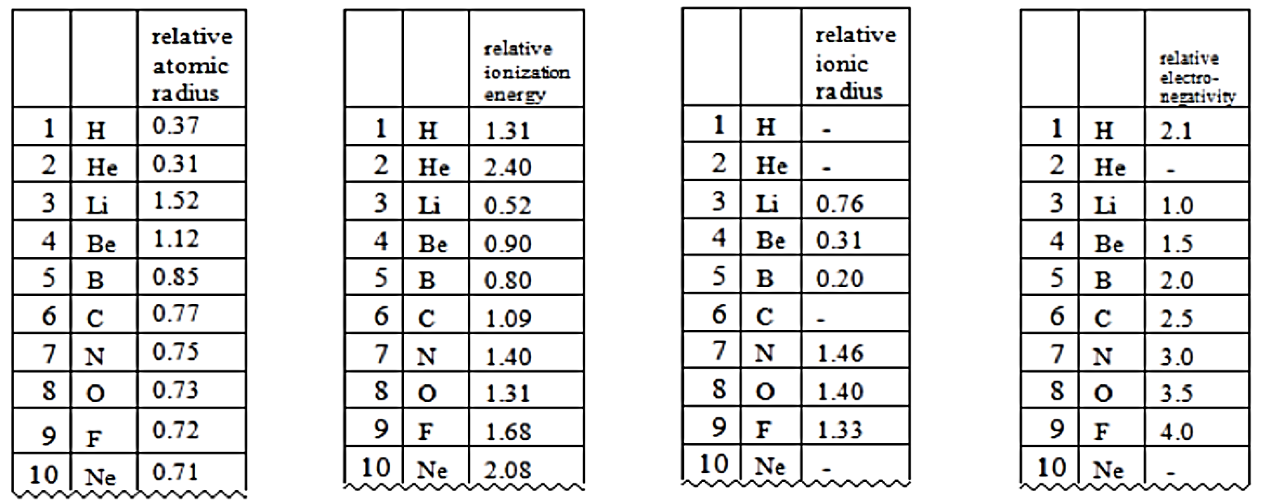
Practice for Data test – Periodic trends

- Which two periodic properties (relative atomic mass, relative ionization energy, relative ionic radius, and relative electronegativity) show a similar trend in their values.

- Identify a trend which relates atomic number to the relative ionisation energy.

- A. Identify a trend which relates atomic number to the relative ionisation energy
b. Use atomic radius as a way of explaining the trend identified in part a

- Identify a trend between ionic radius and one of the other three periodic trends.

- Identify the subshell from which the electron was removed for the first ionization energy of
- He
- Li
- O

